Cloud Computing Mini Project

Title: YouTube Research and save

Liam MARTIN-ESCOFFIER Dongming GUO

Our project consists in a Webpage using the YouTube Api to take all the video of YouTube who contain a keyword, then we display it and the thumbnail of the different video in a list

The User interface will have 3 button one to confirm the research, another to save the research in a mongoDB database and a load to redirect to a page where we can look at the history of research and do the research again.

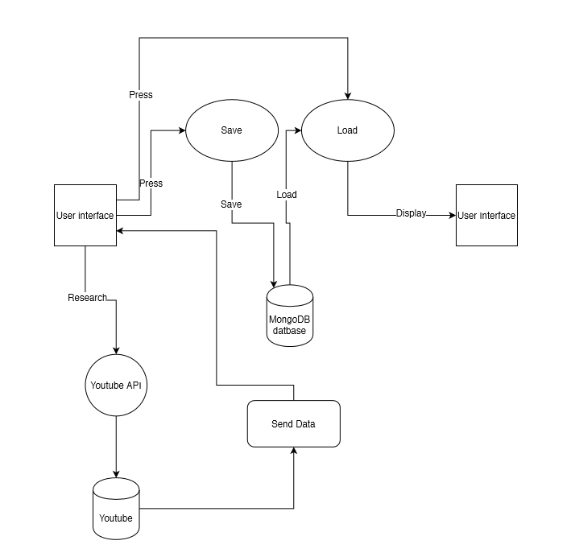

Technologies:

* HTML
* JavaScript
* CSS
* MongoDB